Historic
Farm Buildings Group Conference

Friday 25 September – Sunday 27 September
2026

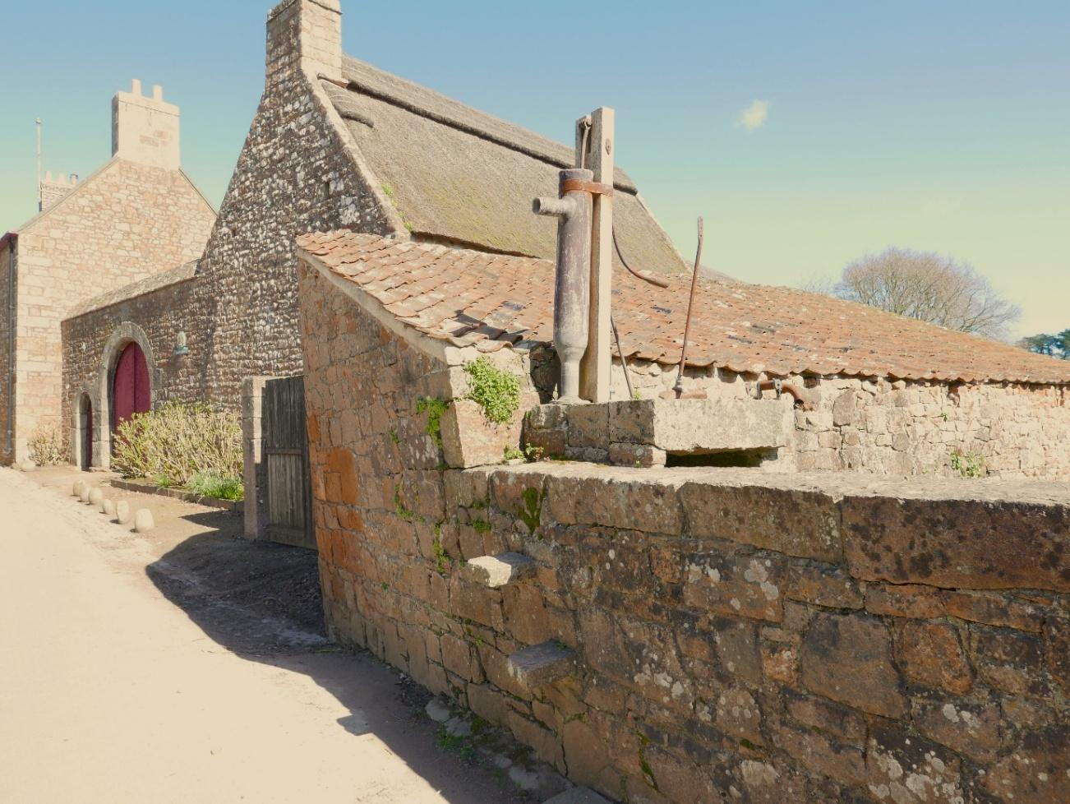

Jersey

Introduction
In September 2026, the HFBG will be organising a weekend conference in Jersey, Channel Islands which will explore the Island’s rich history of rural architecture. The itinerary is being coordinated by local residents Jane and Nick Aubin. The programme may be subject to change; a more detailed one will be distributed later.
Programme

Due to the narrow roads on the Island and need to access properties with limited parking, a minibus will transport participants over the weekend which will pick up and drop off in St Helier each day.
Note that toilet facilities will be available at some sites being visited and not just at lunchtime. There will also be opportunities for you to purchase refreshments at some locations.

Day 1: Friday 25 September (half day)
- 13.00 – Minibus departs St Helier
- 13.15 – 17.00 Visit farming sites. Return to St Helier
- 17.15 – 18.30 Evening Talk - Société Jersiaise Member’s Room, St Helier

Day 2: Saturday 26 September
- 08:30 – Minibus departs St Helier
- 09.00 – 10.45 Walk around the parish of St Mary
- 11.00 – 17.15 Visit farming sites. Return to St Helier
A sandwich lunch will be included in the visit.
There will be the opportunity to have dinner together in St Helier.

Day 3: Sunday 27 September
- 09:00 – Minibus departs St Helier
- 09:15 – 17:00 Visit farming sites. Return to St Helier
A lunch will be included in the visit.
Accommodation
Participants will be expected to make their own travel arrangements to Jersey and book accommodation. There is a range of accommodation in St Helier (Town). You can find information on the Visit Jersey website (https://www.jersey.com) or perhaps offers with airlines that fly to Jersey. If you intend to walk to the minibus pick up (location to be decided but likely near the bus station area) then Havre des Pas is a little out of the way. The Société Jersiaise Member’s Room is on Pier Road and the evening meal will also be in St Helier.
If you decide to stay in Jersey longer than the weekend there are plenty of heritage sites to visit including Jersey Heritage Trust, National Trust and Jersey (Occupation) War Tunnels. The north and west coasts have coastal walks with impressive views.
Travel
Airlines – Currently Loganair, EasyJet and British Airways fly into Jersey Airport.
Ferry – Services are provided by DFDS (https://dfds.com). The timescales are tight but there appears to be a 15% offer off fares to Jersey from the UK on bookings made before 2 March.

Optional Saturday Meal
The organisers will book a restaurant on Saturday evening when numbers have been ascertained. Set menus with a choice of courses will be sent closer to the time.
National Trust Membership & Entrance Fees
Entrance to the Hamptonne Country Life Museum, which will be included in the weekend visit, is free to both Jersey Heritage and UK National Trust members so please bring your NT membership card with you if you have one. This should enable all participants free entry as one of the organisers is able to take 6 people in for free. Please note that English Heritage membership (and NT membership) does not give free access to other Jersey Heritage sites. The Botanic Gardens & Samarès Manor visit entrance fee is included in the cost fee.
Insurance
As a UK resident you are entitled to urgent health care in Jersey but not transfers to the UK. The organisers highly recommend that you have adequate travel and health insurance to cover you visit to the island.
Health and Safety
To ensure that you have a pleasant and safe weekend the following notes may be helpful.
Please wear appropriate footwear according to walking and weather conditions. On Saturday morning it is intended to walk for about 1 hour around the parish of St Mary which is mainly flat with a moderate incline. If this is likely to be an issue, then the organisers will need to be informed so that alternative arrangements can be made.
Currently it is not expected that we will be entering people’s homes but, if this does occur, participants will be asked to leave bags and rucksacks before entering to avoid causing any unintended damage or distress.
Outside, surfaces can be slippery and uneven. Care needs to be taken whilst moving around agricultural buildings.

Historic Farm Buildings Group Conference
25 – 27 September 2026, Jersey
BOOKING FORM
I/We would like to attend HFBG 2026 to Jersey

Numbers are limited to 20 people, so we will prioritise HFBG members on a first come, first served basis but will keep a waiting list in case of cancellations.
Please note: in the event of your cancellation, we will endeavour to fill the place and offer a refund but cannot guarantee to do so. If costs have been incurred, we may not be able to offer a full refund.
Participants are expected to make their own Travel and Accommodation arrangements to Jersey.
NAME(S) & PLACE OF ORIGIN (to appear on your name badge)
……………………….…………………………………………………………………………………………………………….....
ADDRESS …………………………………………………………………………………………………………………………………………
…………………………………………………………………………………………………………………………………………
POSTCODE …………………………………………… TEL. NO. (mobile preferred) …………………………………………….
EMAIL (to only be used for information regarding the visit)
All further information will be sent by email so please provide one

……………………………………………………………………………………………………………………………………….
Special Dietary Requirements
(Please list below; if this form is for two people, please note which this refers to)

……………………………………………………………………………………………………………………………………….
……………………………………………………………………………………………………………………………………….
The cost is:
Members: £ 150 per person
Non-members: £ 165 per person
The cost of the Visit includes: Handbook, two lunches, the minibus hire, entry fee and one year’s subscription to the Historic Farm Buildings Group for those who are not paid-up members of the Group (for insurance purposes).

If you would like to join the evening meal on the Saturday evening, please indicate yes or no: (Y/N)

This will be at an additional cost. A menu and costs will be circulated to those who are interested nearer the time.

If you are a National Trust member please indicate: (Y/N)

Please E-MAIL your completed booking form (2 pages) to hfbgtreasurer@gmail.com.
Or post to the address below (of the Treasurer).
And POST your cheque*, MADE PAYABLE TO: “Historic Farm Buildings Group”
TO: Mike Kingsbury (Treasurer) High Brent, Spinney Lane, Arnside, Carnforth, LA5 0EP (hfbgtreasurer@gmail.com)

*If you are using a company cheque or one not in the applicant’s name, please clarify within the envelope.

Or electronic bank TRANSFER, indicating your name and ‘visit booking:
Account name: Historic Farm Buildings Group
Sort Code: 20-98-61
Account no.: 90457388
Please indicate your payment method below:

I/We have read the above and have posted a cheque

OR I/We have paid by bank transfer
Delegates may pay by bank transfer, or by cheque, and booking forms can be received via email or by post. It is the receipt of payment that confirms your place.

AMOUNT OF CHEQUE/BANK TRANSFER: £…………………………..

Signed …………………………………………………………… Dated ………..........................

Bookings to be received no later than 25 August 2026
NB: Please note that the Historic Farm Building Groups’ Insurance covers third party insurance and injuries caused by one member of the group to another member of the group but not an injury caused to oneself. If you are concerned about this, you should take out your own personal accident insurance.

If you need any further info, please get in touch with Jane Aubin (visit organiser) – janeaubinhr@gmail.com or Mike Kingsbury hfbgtreasurer@gmail.com

